Day 8 - 11/6/2025
Barghavi Bethu
112728766 – bethubal

Task 1:

What do you understand by exceptions?

Exceptions are the errors that occurs during execution of program, which disturbs the normal behavior of program. These will either allow the program to run by skipping it or terminate the program.

Task 2:

What are the categories of Exceptions do we have in Java? What are they?

There are 3 types of exceptions.
1. Checked Exceptions – Exceptions found during compilation of a program.
2. Unchecked Exceptions - Exceptions occurs during runtime of program.
3. Errors – these are nor considered to be exceptions but more like which are beyond the control of the user.

Task 3:

Can you try the below code snippet and let me know which kind of exception is this ?

What is the output of the code..?

// Java program to demonstrates handling
// the exception using try-catch block
import java.io.*;

class Geeks {
public static void main(String[] args)
{
int n = 10;
int m = 0;

try {

// Code that may throw an exception
int ans = n / m;
System.out.println("Answer: " + ans);
}
catch (ArithmeticException e) {

// Handling the exception
System.out.println(
"Error: Division by zero is not allowed!");
}
catch (ArithmeticException e) {

// Handling the exception
System.out.println(
"Error: Division by zero is not allowed!");
}
finally {
System.out.println(
"Program continues after handling the exception.");
}
}
}
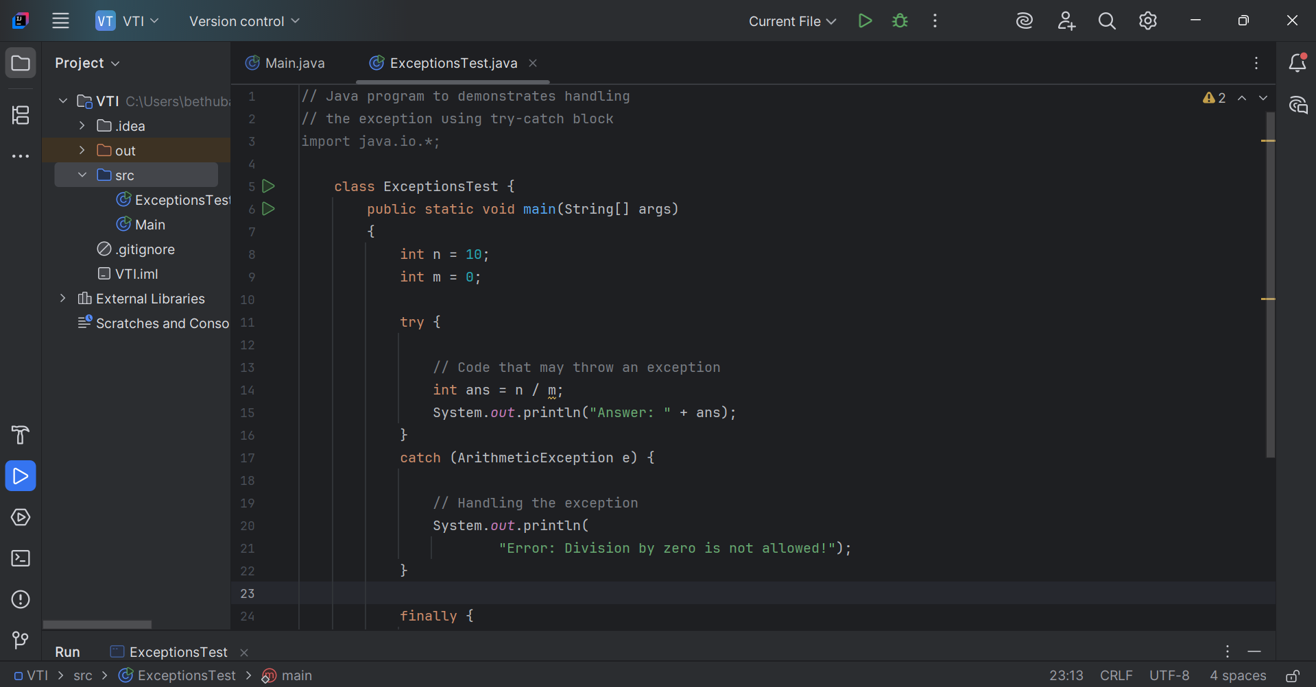
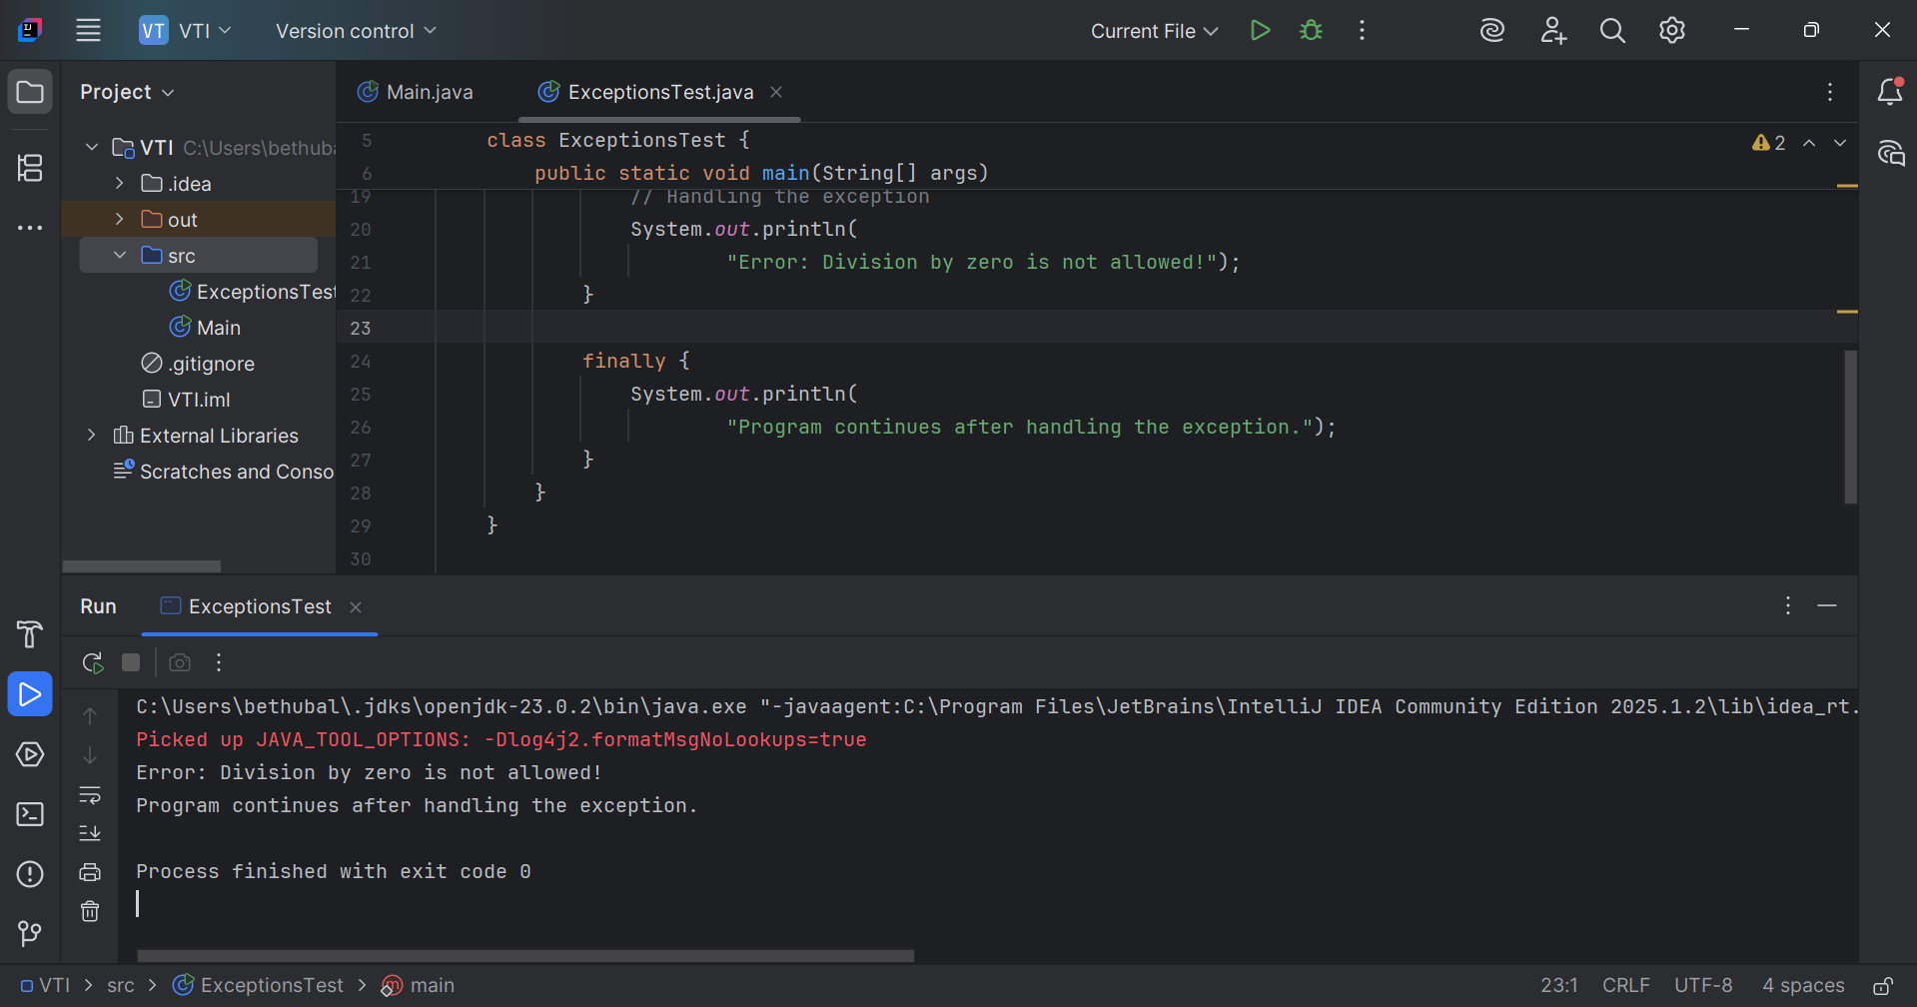

This code gives arithmetic exception which occur at runtime, so it falls under unchecked exception.

Task 4:

List of checked and unchecked exceptions.
Unchecked exception:
- NullPointerException
- ClassCastException
- ArithmeticException
- DateTimeException
- ArrayStoreException
Checked Exception:
- ClassNotFoundException
- SocketException
- SQLException
- IOException
- FileNotFoundException

Task 5:

Try with Multiple catch blocks …. Execute the below code snippet n display the out .. along with reason..

public class ExcepTest {

public static void main(String args[]) {
try {
int a[] = new int[2];
int b = 0;
int c = 1/b;
System.out.println("Access element three :" + a[3]);
}
catch (ArrayIndexOutOfBoundsException e) {
System.out.println("ArrayIndexOutOfBoundsException thrown :" + e);
}catch (Exception e) {
System.out.println("Exception thrown :" + e);
}
System.out.println("Out of the block");
}
}

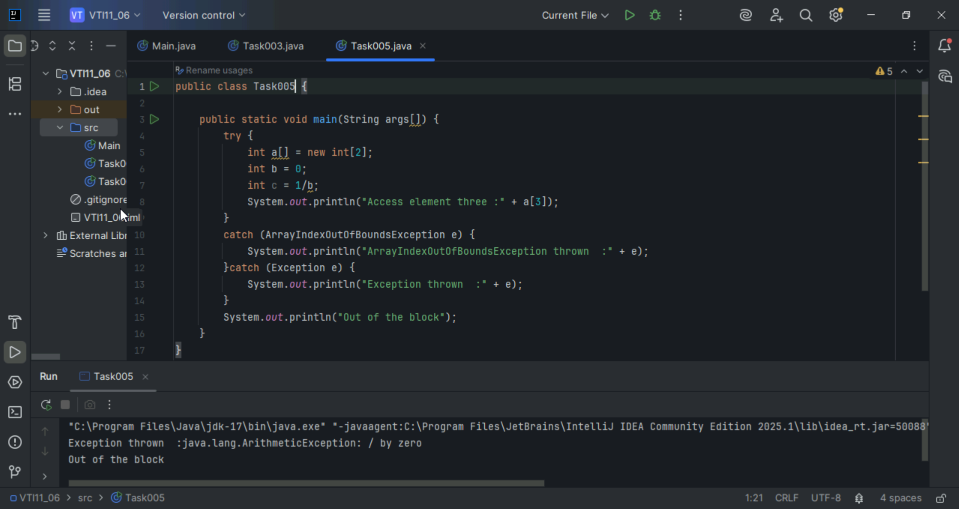

Task 6:

What is the output of the below code… give your reason for the output

public class ExcepTest {

public static void main(String args[]) {
try {
int a[] = new int[2];
int b = 0;
int c = 1/b;
System.out.println("Access element three :" + a[3]);
}
catch (ArithmeticException e) {
System.out.println("ArithmeticException thrown :" + e);
}
catch (ArrayIndexOutOfBoundsException e) {
System.out.println("ArrayIndexOutOfBoundsException thrown :" + e);
}catch (Exception e) {
System.out.println("Exception thrown :" + e);
}
System.out.println("Out of the block");
}
}
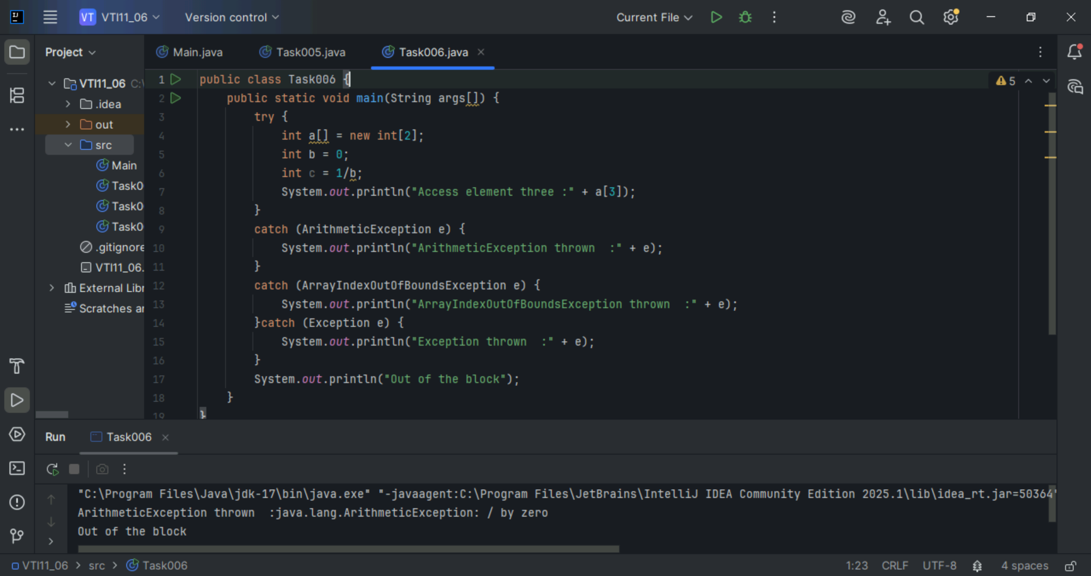

Task 7:

In the below code we are having use multiple catch in a single statement: find the output and try to understand the code..

public class ExcepTest {

public static void main(String args[]) {
try {
int a[] = new int[2];
int b = 0;
int c = 1/b;
System.out.println("Access element three :" + a[3]);
}
catch (ArrayIndexOutOfBoundsException | ArithmeticException e) {
System.out.println("Exception thrown :" + e);
}
System.out.println("Out of the block");
}
}
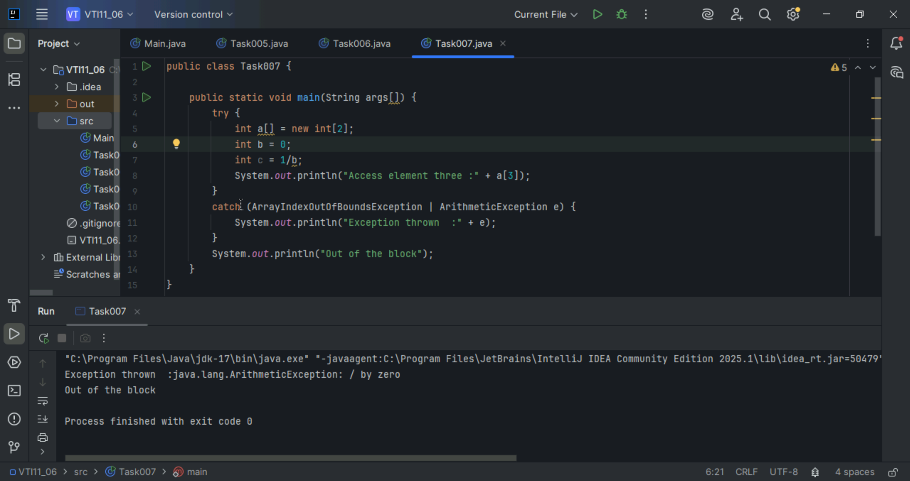

Task 8

public class ExcepTest {

public static void main(String args[]) {
try {
int a[] = new int[2];
try {
int b = 0;
int c = 1/b;
}catch(Exception e) {
System.out.println("Exception thrown: " + e);
}
System.out.println("Access element three :" + a[3]);
}
catch (ArrayIndexOutOfBoundsException e) {
System.out.println("Exception thrown: " + e);
}
System.out.println("Out of the block");
}
}
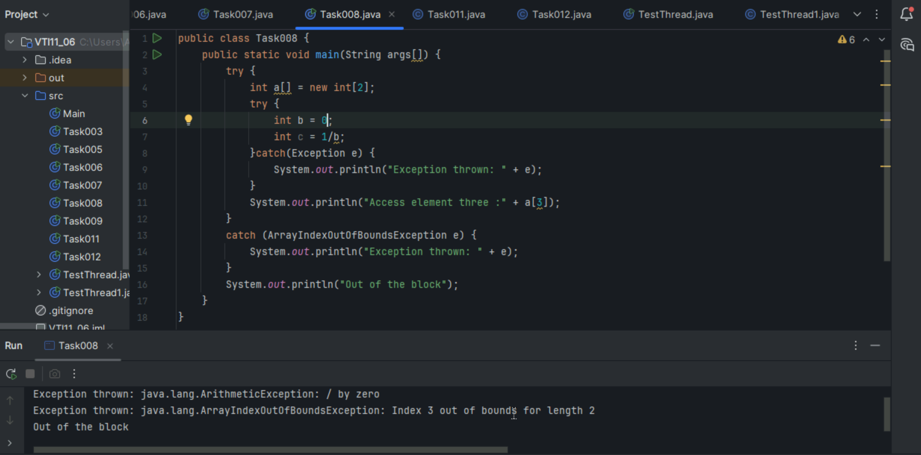

Task 9:

// Demonstrating how to throw an exception
class MyClass {

static void fun() throws IllegalAccessException
{
System.out.println("Inside fun(). ");
throw new IllegalAccessException("demo");
}

public static void main(String args[])
{
try {
fun();
//method2(); → arrayindex…
//Method3() —> file not found….
}
catch (IllegalAccessException e) {
System.out.println("Caught in main.");
}
}
}

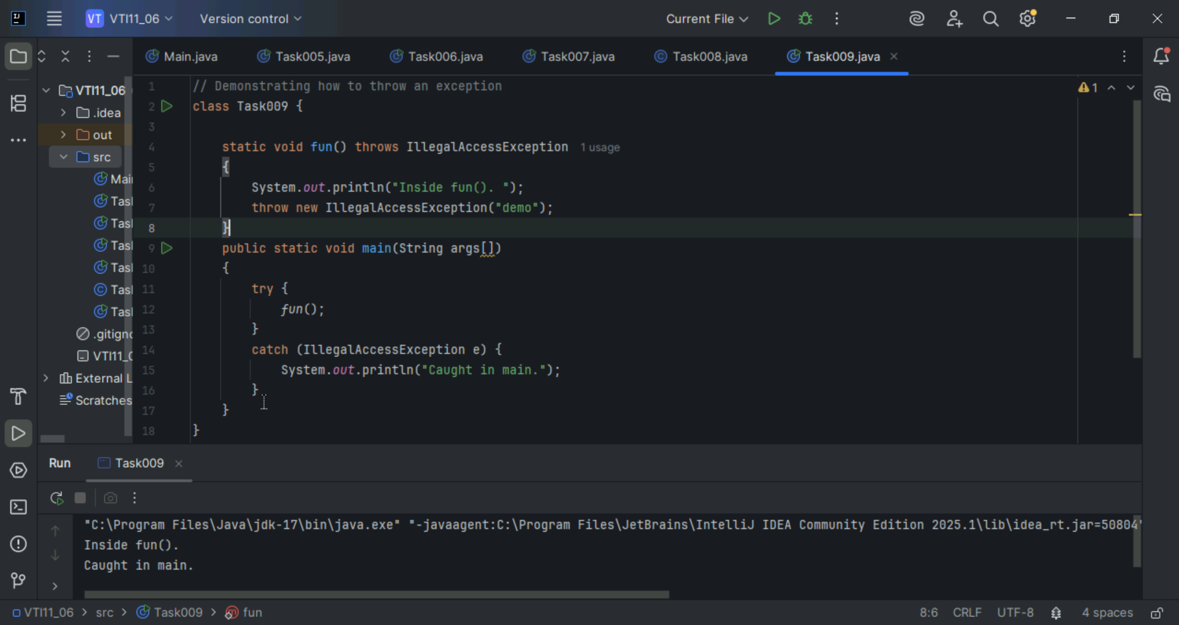

Task 11:
Wap to create an array list to display 10 elements using for loop.

import java.util.ArrayList;
class Main {
public static void main (String[] args) {

// Creating an ArrayList
ArrayList<Integer> a = new ArrayList<Integer>();
// Adding Element in ArrayList
a.add(1);
a.add(2);
a.add(3);

// Printing ArrayList
System.out.println(a);
}
}
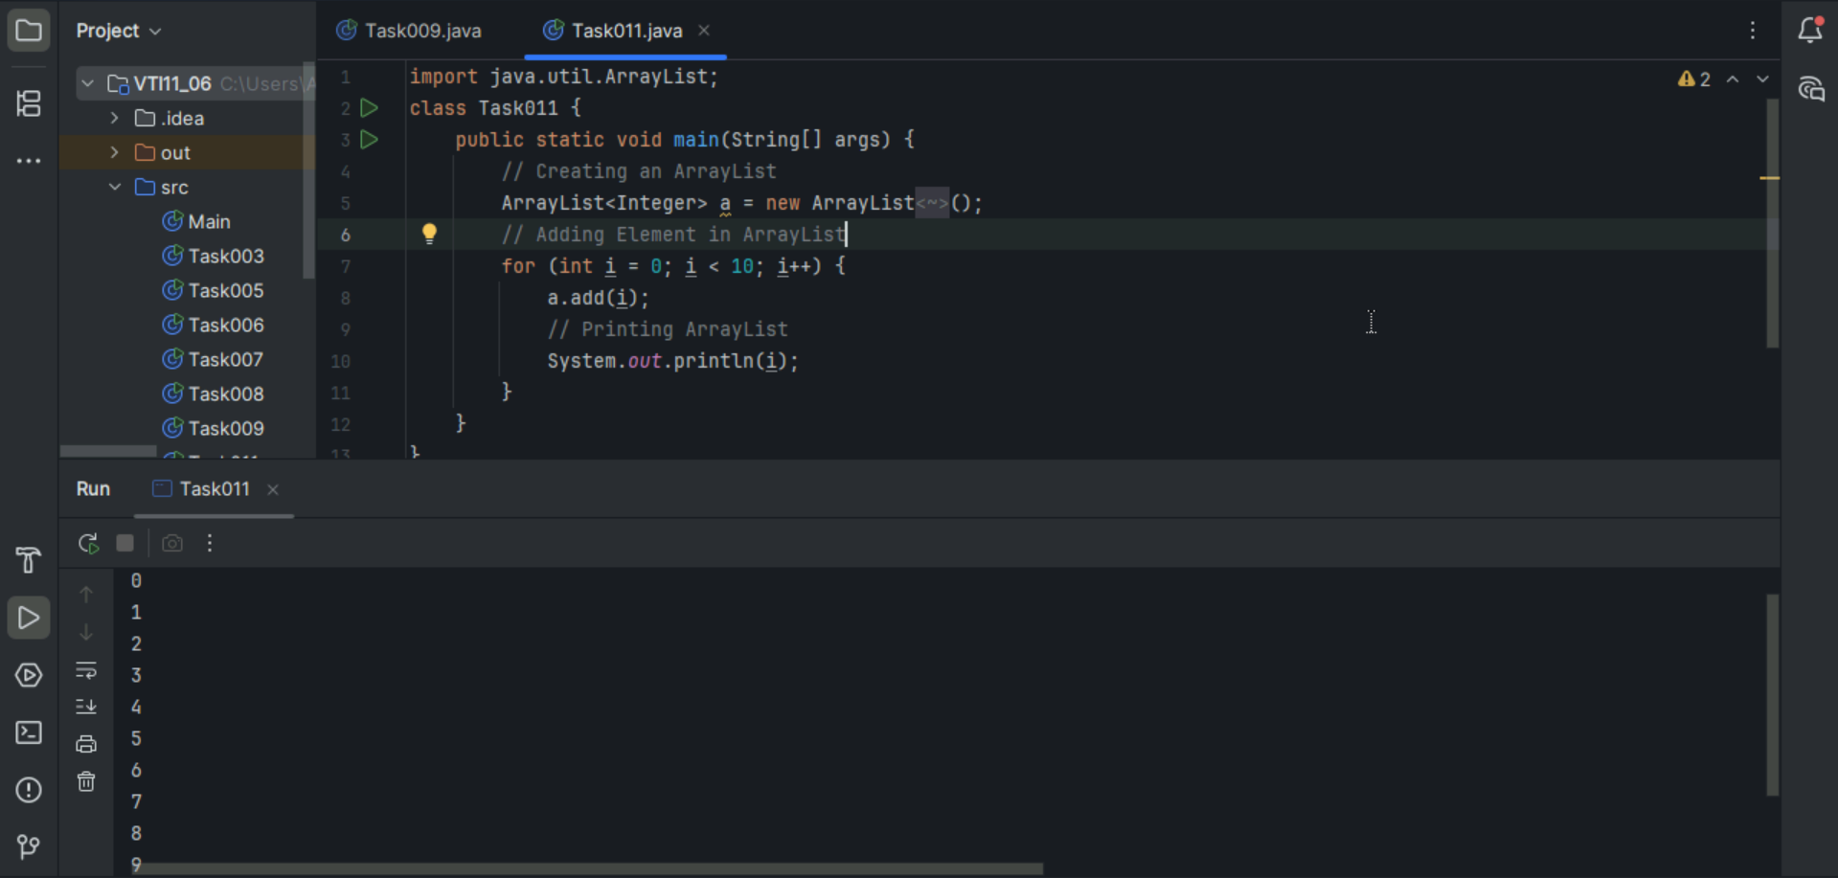

Task 12:
Find the output of the be code snippet..
// Addition, Deletion and Updation of Element
import java.util.*;
class Main {
public static void main(String args[]){
ArrayList<String> al = new ArrayList<>();
al.add("Prasunamba");
al.add("Meher");
System.out.println("Orignal List : "+al);

al.add(1, "Hello");
System.out.println("After Adding element at index 1 : "+ al);

al.remove(0);
System.out.println("Element removed from index 0 : "+ al);

al.remove("Prasunamba");
System.out.println("Element Prasunamba removed : "+ al);

al.set(0, "K");
System.out.println("List after updation of value : "+al);
}
}
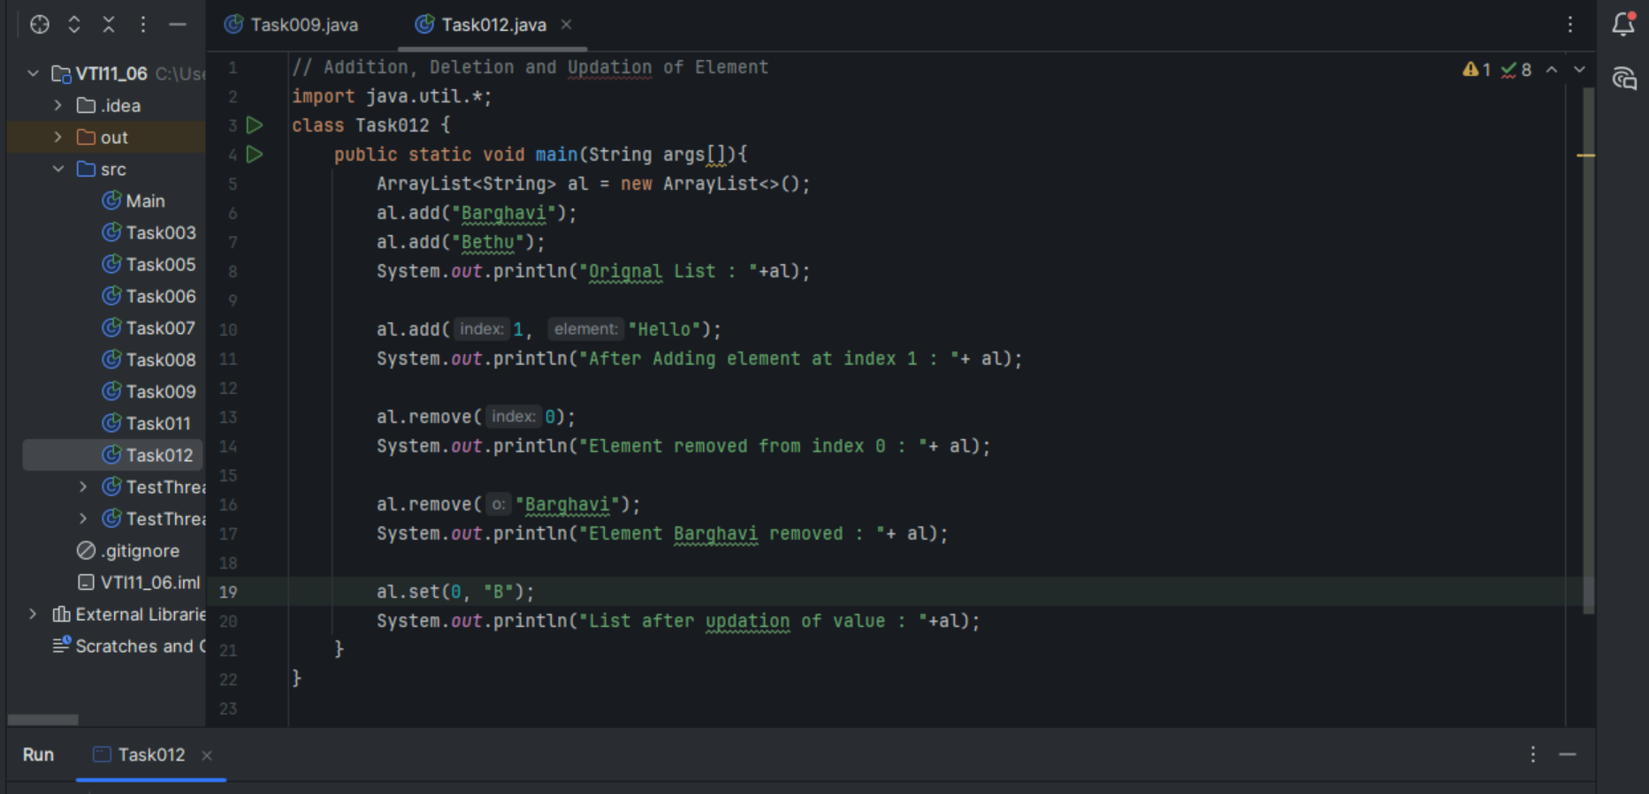
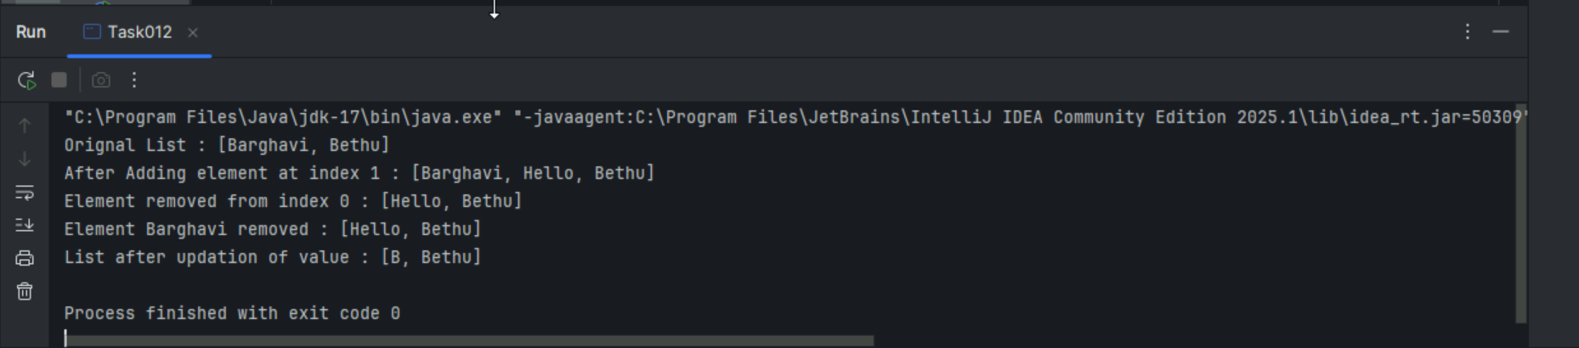

Task 013:
Run the code and see how the user defined exception works..
User defined Exception:
// A Class that represents user-defined exception
class Customer extends Exception {// predefined class Exception
public Customer(String m) { // constructor with parameters
super(m); // parent class constructor
}
}
// A Class that uses the above Customer
public class setText {
public static void main(String args[]) {
try {
// Throw an object of user-defined exception
throw new Customer("This is a custom exception");
}
catch (Customer ex) {
System.out.println("Caught");
System.out.println(ex.getMessage());
}
}
}
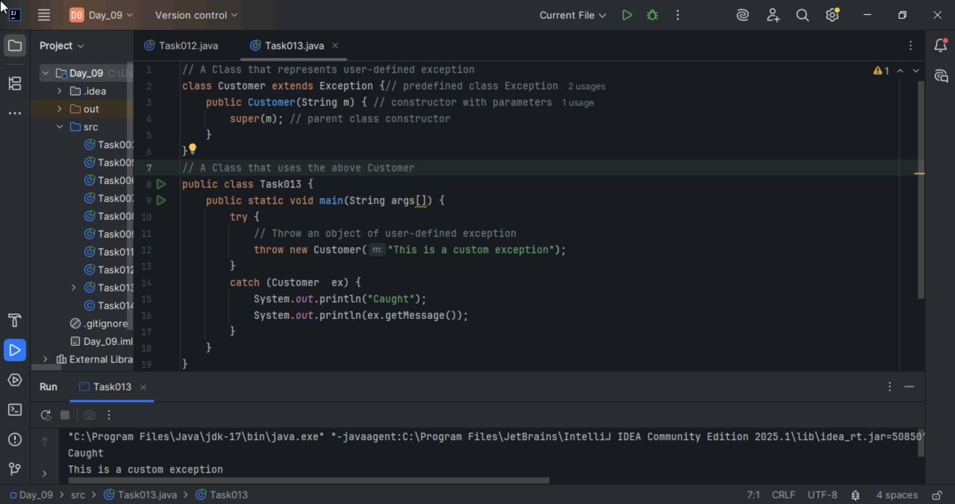

Task 014:
Inheritance, Abstraction concepts.
Inheritance: Inheritance in Java is a mechanism where one class (called a subclass or child class) acquires the properties and behaviors (fields and methods) of another class (called a superclass or parent class).

Abstraction:
Abstraction is one of the four main OOP concepts (along with encapsulation, inheritance, and polymorphism). It means hiding the internal implementation details and showing only the essential features of an object. Used to To reduce complexity, To focus on what an object does rather than how it does it, and to provide a blueprint for derived classes (in case of abstract classes or interfaces).

Task 015:
What is the output of the below code snippet.. Explain ..
class OuterClass {
int x = 10;
class InnerClass {
int y = 5;
}
}

public class Main {
public static void main(String[] args) {
OuterClass myOuter = new OuterClass();
OuterClass.InnerClass myInner = myOuter.new InnerClass();
System.out.println(myInner.y + myOuter.x);
}
}
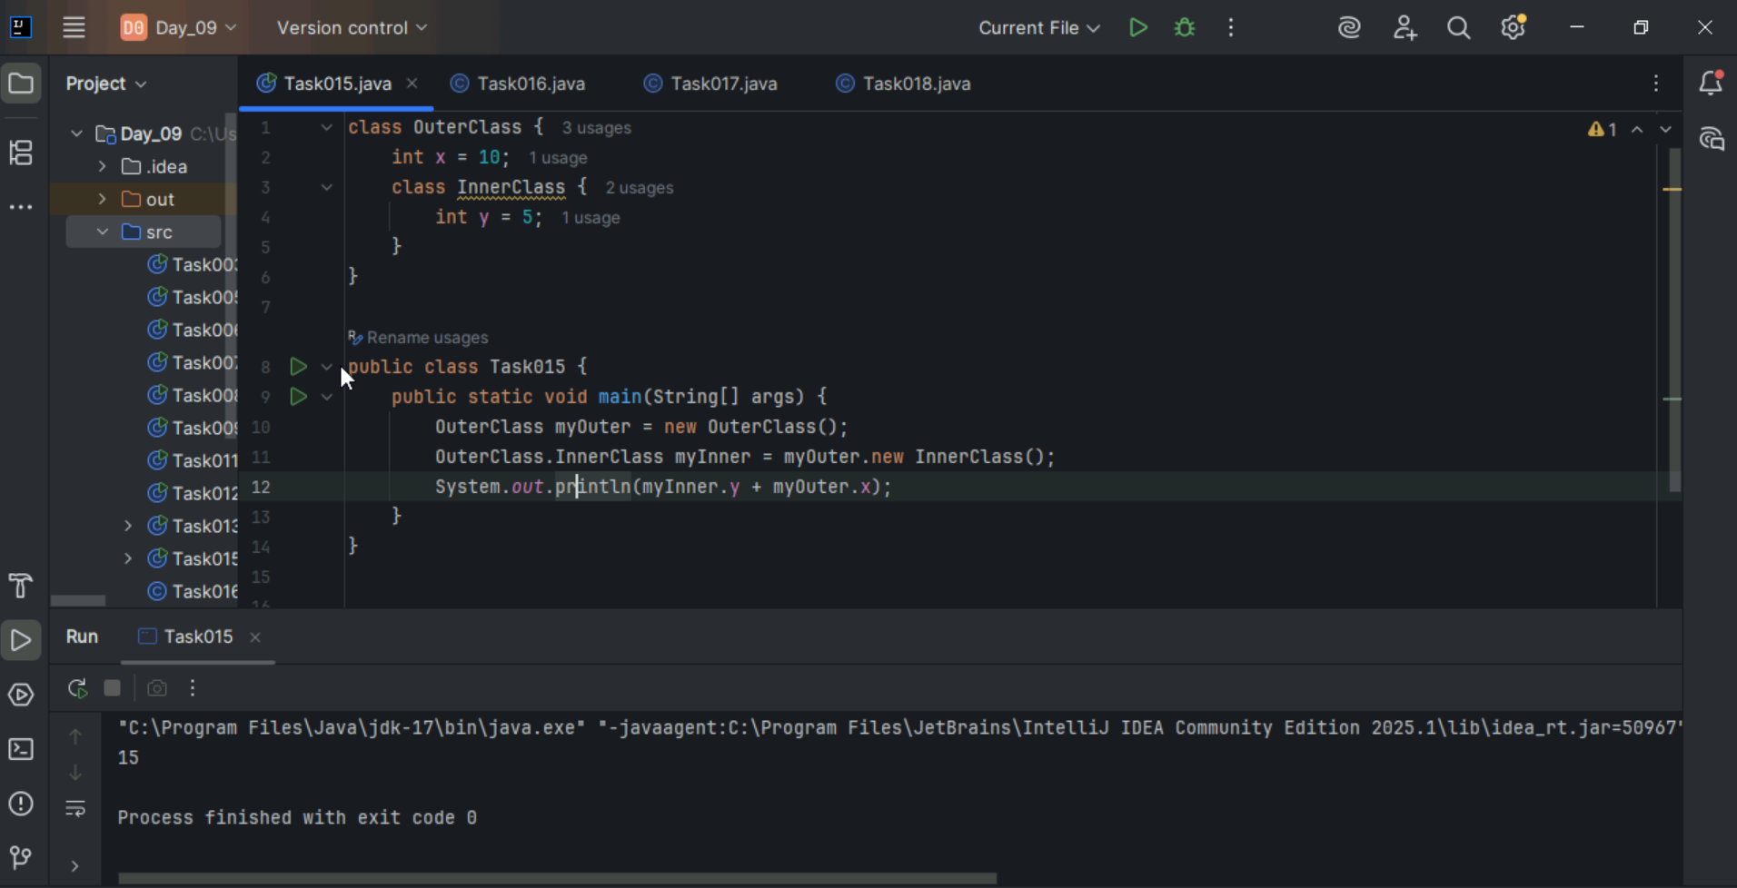

Task 016:
Use the above code and make the inner class as private and see the output..
Ex: private class InnerClass {
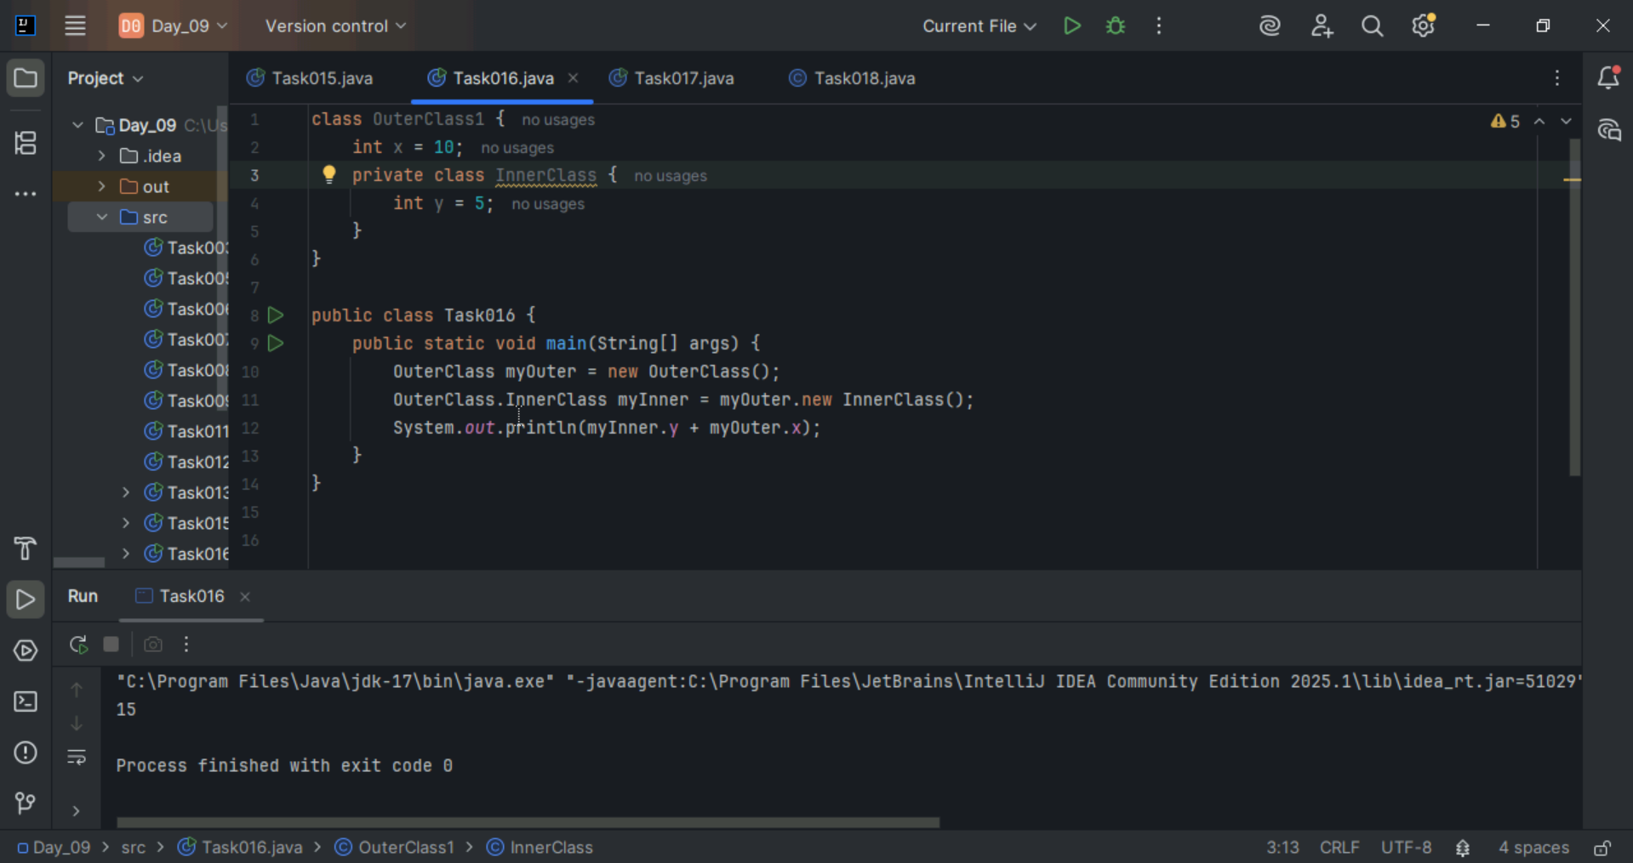

Task 017:
Use the above code Task 015 and make the inner class static … see the output and explain..
Ex: static class InnerClass {

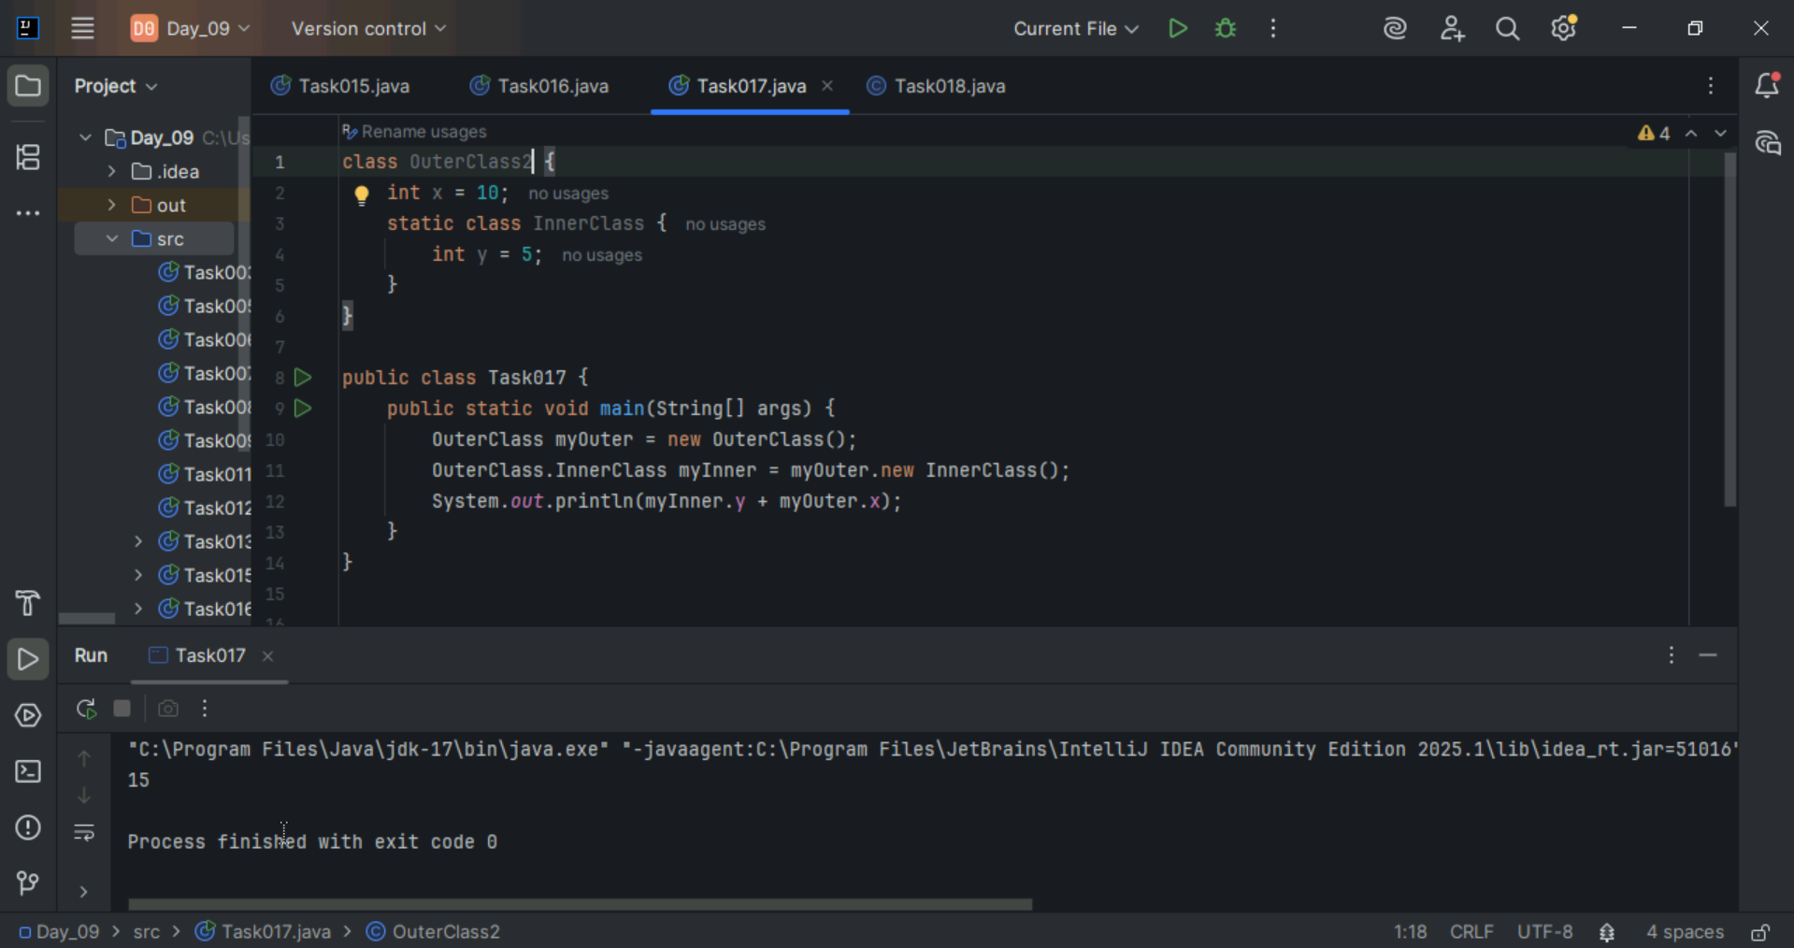

Task 018:
Use the above code Task 015 and create a method in innerclass and return the outer class variable
class OuterClass{
Int x = 50;
Class InnerClass {
Public int innerMethod() {
Return x;
}
}
}

Public class DriverClass {
psvm(){
OuterClass myOuter = new OuterClass();
OuterClass.InnerClass myInner = myOuter.new InnerClass();
System.out.println(myInner.innerMethod());
}
}
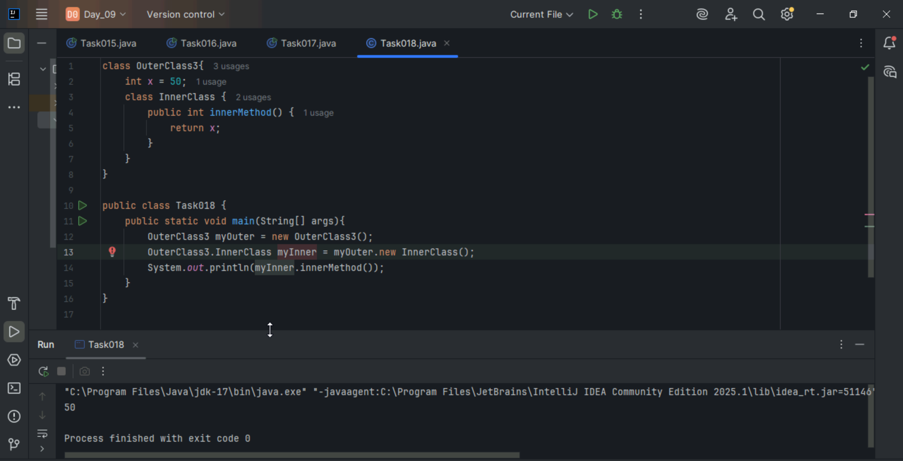

Task 019:

class OuterClass {
int x = 10;

static class InnerClass {
static int y = 5;
}
}

public class Main {
public static void main(String[] args) {
OuterClass.InnerClass myInner = new OuterClass.InnerClass();
System.out.println(myInner.y);

}
}
